Table name: google_salaries

| **Empid** | **first_name** | **last_name** | **department** | **education** | **salary** |
| --- | --- | --- | --- | --- | --- |
| 376 | Gary | Stokes | Accounting | Master | 56760 |
| 377 | Lorenzo | Cortez | Accounting | Doctorate | 74127 |
| 378 | Roberta | Mcgee | Administration | Primary | 23987 |
| 379 | Myrtle | Munoz | Administration | Primary | 31079 |
| 380 | Molly | Walker | Administration | Primary | 20725 |
| 381 | Maria | Simmons | Administration | Secondary | 39723 |
| 382 | Muriel | Hernandez | Administration | Bachelor | 58555 |
| 383 | Andres | Watson | BI | Bachelor | 56834 |
| 384 | Wayne | Leonard | BI | Master | 65180 |
| 385 | Julius | Poole | BI | Master | 55842 |

Table name: google_laptop

| **LaptopId** | **Empid** | **Brand** | **Price** |
| --- | --- | --- | --- |
| 100 | 376 | Bran1 | 567600 |
| 101 | 377 | Bran3 | 741270 |
| 102 | 378 | Bran4 | 239870 |
| 103 | 379 | Bran10 | 310790 |
| 104 | 380 | Bran2 | 207250 |
| 105 | 381 | Bran5 | 397230 |
| 106 | 382 | Bran8 | 585550 |
| 107 | 383 | Bran9 | 568340 |
| 108 | 384 | Bran7 | 651800 |
| 109 | 385 | Bran6 | 558420 |

**Write the join query for which employee is assigned for which laptop**

Answer:

SELECT

gl.LaptopId,

gl.Empid,

gl.Brand,

gl.Price,

gs.first_name,

gs.last_name

FROM

google_laptop gl

JOIN

google_salaries gs

ON

gl.Empid = gs.Empid;

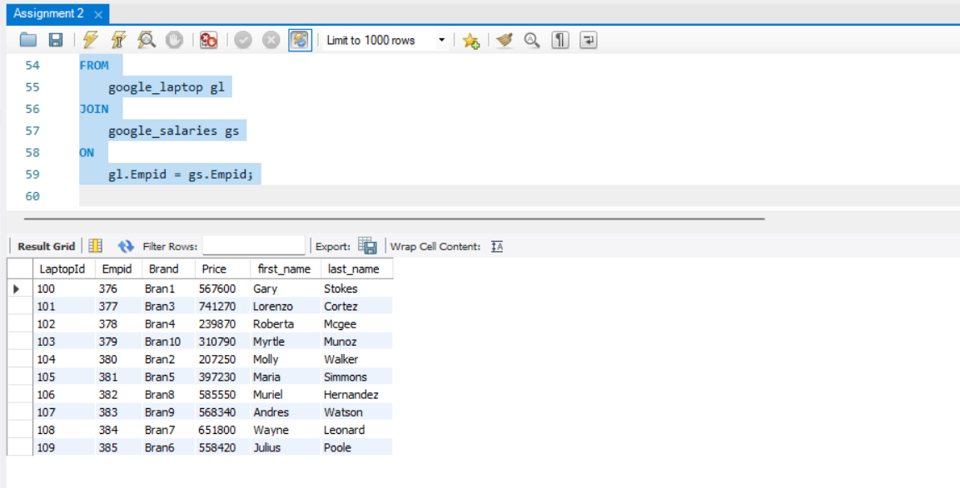

Output sample

| **LaptopId** | **Empid** | **Brand** | **Price** | **first_name** | **last_name** |
| --- | --- | --- | --- | --- | --- |
| 100 | 376 | Bran1 | 567600 | Gary | Stokes |
| 101 | 377 | Bran3 | 741270 | Lorenzo | Cortez |
| 102 | 378 | Bran4 | 239870 | Roberta | Mcgee |
| 103 | 379 | Bran10 | 310790 | Myrtle | Munoz |
| 104 | 380 | Bran2 | 207250 | Molly | Walker |
| 105 | 381 | Bran5 | 397230 | Maria | Simmons |
| 106 | 382 | Bran8 | 585550 | Muriel | Hernandez |
| 107 | 383 | Bran9 | 568340 | Andres | Watson |
| 108 | 384 | Bran7 | 651800 | Wayne | Leonard |
| 109 | 385 | Bran6 | 558420 | Julius | Poole |

Bottom of Form